Job Sheet Solution User Guide

Date: | 24th July 2016
Version No: | 1.0
Status: | Release

  - Three Grey Monkeys

Contents
Installation 2
Requirements 2
Import Solution 2
Configuration 2
Assign Security Role 2
Configure The Counter 2
Counter Configuration Details 3
Using Job Sheet Solution 4
Creating a Job Sheet 4
Job Sheet Field Information 5
Task 5
Appointment 6
Customer Approval Webpage 6
Job Sheet 6
Appointment 6
Customer Approval Form Details 7
Job Sheet Completion Notifications 7
Microsoft Exchange 8

Installation

Requirements
- CRM 8.0 or higher
- JobSheetSolution.zip
- Web Server

Import Solution
- Navigate to Settings > Solutions and select Import

Configuration
To ensure Job Sheet Solution works correctly, it is necessary to assign the Job Sheet security roles and ensure that a web server, which hosts the approval webpage, is setup for your organisation. In addition, we recommend to configure the counter to enable the Job Sheet ID functionality.

Assign Security Role
Job Sheet Solution includes two security roles to provide appropriate levels of access to the Jobsheet records. The roles are Jobsheet Full-Access and Jobsheet Read-Only. We recommended assigning managers with JobSheet Full-Access and assigning Engineers with JobSheet Read-Only.
- Navigate to Settings > Security and select Users
- Single-click on a user
- Select Manage Roles
- Choose JobSheet Full-Access or JobSheet Read-Only and press OK

Configure The Counter
Job Sheet Solution provides optional Job Sheet ID generation for improved record management. This involves configuration of a counter. Counters can be configured to suit your requirement. Once configured, all new records will be given a unique ID.
- Navigate to Settings > Solutions
- Double-click on TGMJobsheet from the list of solutions
- Open Configuration tab
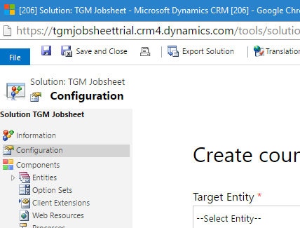

- From the Target Entity picklist select Job Sheet

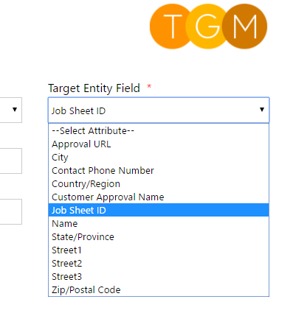
- From the Target Entity Field picklist select Job Sheet ID

- Optionally provide advanced configuration and then select Create. The configuration below will generate ID’s of the form [JS:000001]. If you do not provide an advanced configuration, then the ID only consists of a number.
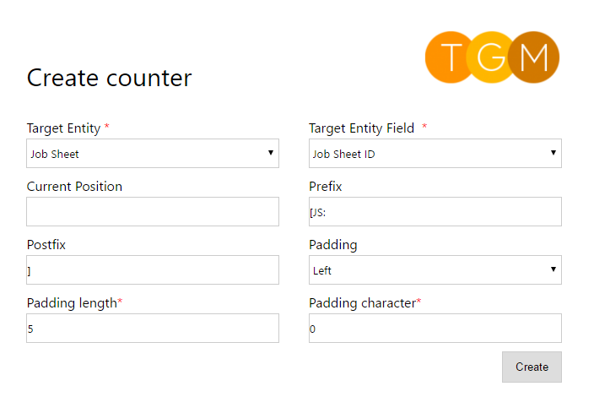

Counter Configuration Details
Field | Data Type | Required | Description
Target Entity | Picklist | Yes | Select the Job Sheet option to ensure all new Job Sheets have ID generations.
Target Entity Field | Picklist | Yes | The target entity field is a text field that will contain the ID value. When a field is selected, an ID will be generated and placed in that field. Select the Job Sheet ID field.
Current Position | Number | No | Current position means the current global ID value used in ID generation. For example, if current position is 1, then the next record ID would be 2. This value is useful when importing a set of Job Sheets. By setting current position to the highest ID value imported, then it ensures all new Job Sheets have a unique ID.
Prefix | Text | No | A prefix is a combination of meaningful characters that comes before an ID. Padding is used to improve readability of IDs. E.g. JS:10012 uses a prefix of JS: which indicates the ID related to a Job Sheet.
Postfix | Test | No | A postfix is a combination of meaningful characters that follows an ID. Postfixes help improve readability of IDs. E.g. [10012] uses a prefix and postfix of square brackets.
Padding | Picklist | No | Padding is the addition of a repeating character before or after the ID value. It is common to provide zero-padded IDs. For example, 000001 is a left-padded ID with the number 0 repeated 5 times. Note, prefixes and postfixes are applied before or after the padding.
Padding length | Number | No | The padding length specifies how many times a padding character is repeated. For example, a padding length of 4 combined with a # (hashtag) character would result in ####.
Padding character | Character | No | A padding character improves readability of an ID value. It is any character, such as a number, letter or special character, that is placed before or after an ID string.
Configure Web Server (Advanced)
- This only applies if your organisation wishes to setup its own web server to host the Customer Approval webpage
- Follow instructions in the README file
- This is found in the root folder of the webpage source code

General Settings
TGM Jobsheet supports additional capabilities, including Office 365 group calendar integration and a job sheet approval web page. A general setting record defines the configuration for these capabilities. Each record is identified by a General Setting Key. For example, the approval webpage URL can only be generated when a general setting exists whose key equals “tgm_jobsheet”. This makes it easier to maintain additional job sheet capabilities.

Jobsheet Approval Webpage
Field | Value | Description
General Setting Key | tgm_jobsheet
String 1 |  | Base URL of the approval page

Office 365 Group Calendar
Field | Value | Description
General Setting Key | tgm_jobsheetgroupcalendar
String 1 | https://outlook.office365.com/owa/?path=/group/  GROUP_EMAIL_HERE/calendar | This field contains the URL of the group calendar, which is used by the “Jobsheet Calendar” menu item.
String 2 |  | GUID of the group, e.g. Engineers

Using Job Sheet Solution

Creating a Job Sheet
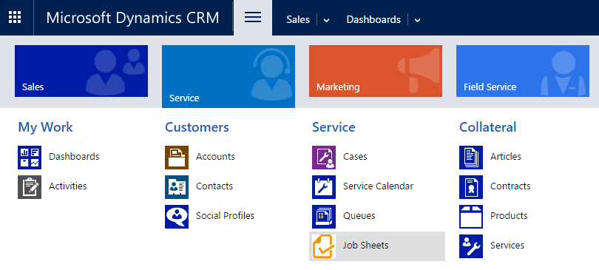
- Navigate to Service > Job Sheets and select New
1

2

3

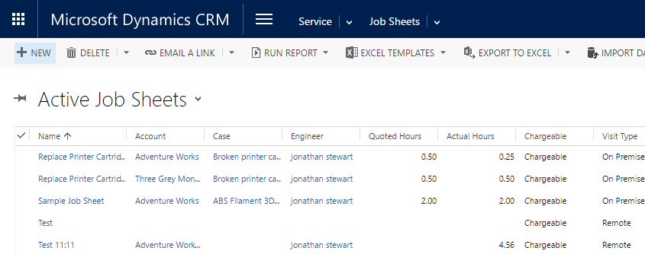

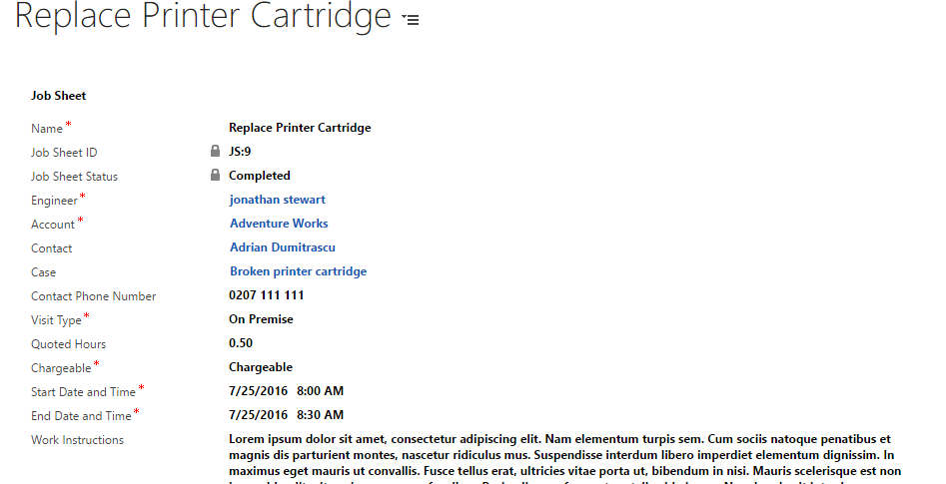
- Populate Job Sheet

Job Sheet Field Information
Field | Data Type | Description
Job Sheet ID | Text | Unique identifier for the Job Sheet.
Job Sheet Status | Option Set | Pending or Completed.
Engineer | Lookup | Lookup to the service engineer user record. This user will be assigned the subsequent task and appointment.
Account | Lookup | Lookup to the customer account receiving the job.
Contact | Lookup | The primary contact for this job.
Case | Lookup | Lookup to a related service case.
Contact Phone Number | Text | Phone number of the primary contact.
Visit Type | Option Set | Remote or on-premise.
Quoted Hours | Decimal | Number of agreed hours for the job.
Chargeable | Option Set | Defines how this job is financed. Available options are Chargeable or Maintenance. Completed charageable jobs generate a “Billable Job Completed” task for the related Account.
Start Date and Time | Date & Time | When the job is planned to start.
End Date and Time | Date & Time | When the job is planned to end.
Work Instructions | Multi Line | Optional description of what the engineer is to do on the job.

Task
- Under Notes & Activities in the Job Sheet record, open the Activities tab and then select the task.
1
2
- Review Task details

Appointment
- Under Notes & Activities in the Job Sheet record, open the Activities tab and then select the appointment.

2
1

- Review the details

Customer Approval Webpage

- Find URL from Job Sheet or Appointment record & load in browser

Job Sheet
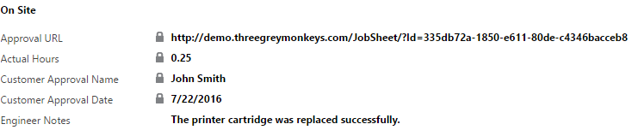

Appointment

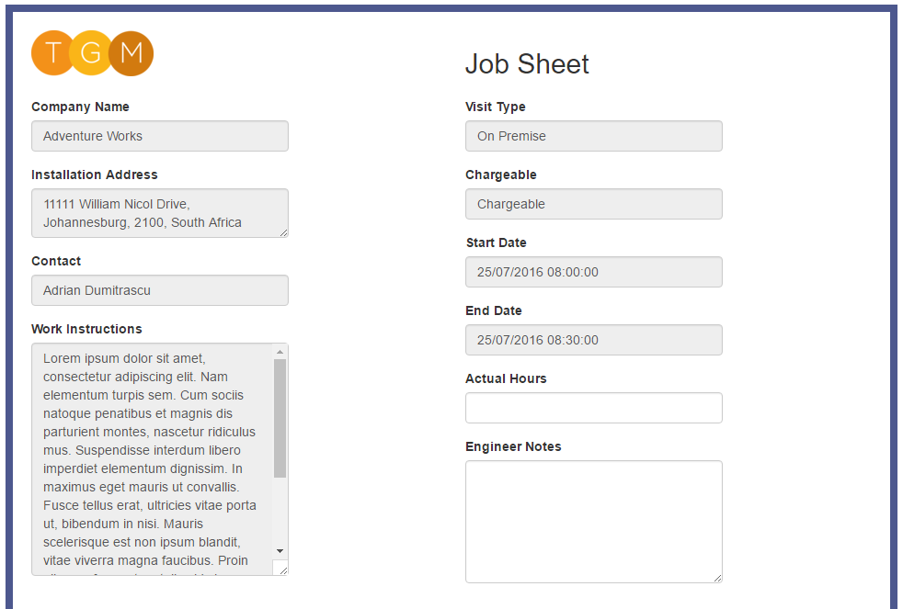
- Populate and Submit Form

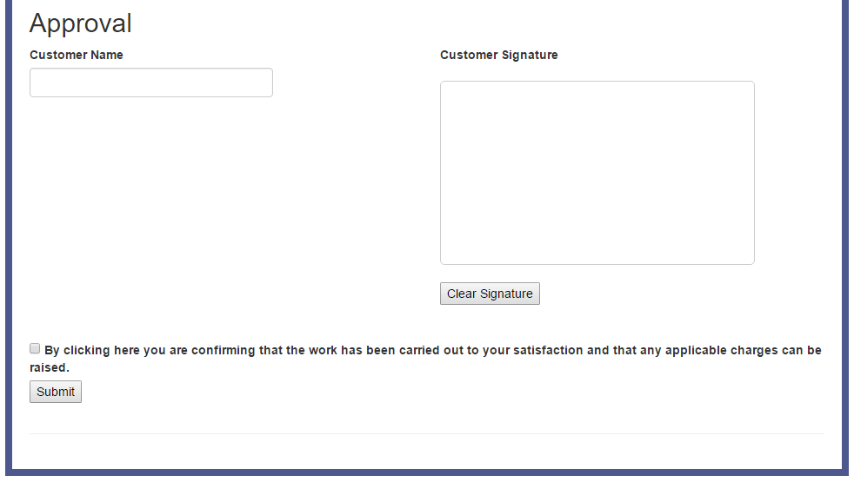

Customer Approval Form Details
Name | Required | Data Type | Description
Actual Hours | Yes | Decimal | The actual hours spent on this job.
Engineer Notes | No | Text | A multi-line entry of notes related to this job.
Customer Name | Yes | Text | The name of the customer approving this job.
Customer Signature | Yes | Image | A digital drawing of the customer signature. This can be provided via touch input or using a mouse. If a mistake is made, then the Clear Signature button can reset the field.
Confirmation Checkbox | Yes | Checkbox | This checkbox confirms that the customer is satisfied with the job.

Job Sheet Completion Notifications
Following submission of the customer approval form, a series of notification events take place. The goal of this process is to inform relevant users and teams about the completion of this job sheet. This means that the right people have the information they need to proceed. Notifications are provided in the form of tasks and emails.
- Job Sheet Completed Task
This is assigned to the Account owner but is only assigned to the Case owner if this Job Sheet has a Case.

- Job Sheet Completed Email
This e-mail is sent from the creator of the Job Sheet. It is delivered to the Account owner but is only delivered to the Case owner if this Job Sheet has a Case. A sample e-mail is shown below.

Dear Mikey,

Job Sheet JS:10 has been completed on 7/22/2016. Further details can be found below.

Account Name: Business Consultants
Contact Name: Mikey Smith
Contact Main Phone: 0202 777777

Account Address:
Street 1
Street 2
Street 3
City
State/Province
Zip/Postal Code
Country/Region

Visit Type: On Premise
Chargeable: Chargeable
Work Instructions: Go to the 3rd floor, ask for Mikey and repair the VoIP telephone system.

Kind Regards,
John Smith

- Billable Job Completed Task
The purpose of this task is to inform the owing team of the Account that they are required to pay for this Job Sheet. It is only created when a Chargeable Job Sheet is completed.

Microsoft Exchange
Server-side synchronisation from CRM to Microsoft Exchange provides automatic synchronisation of e-mail, appointments, contacts and tasks. This functionality complements Job Sheet Solution. Instead of service engineers viewing their Job Sheets in CRM, they can instead view the information they need via their smartphone’s Outlook calendar. As a result, it becomes faster and easier for the service engineer to find the information they need.
To find out more about server-side synchronisation, follow the link below.
https://technet.microsoft.com/en-gb/library/dn531109.aspx

Office 365 Group Calendar
When many job sheets exist in CRM, it can be difficult to manage them using the CRM service calendar. TGM solves this problem by integrating the solution with an Office 365 group calendar. To set this up, TGM will require the credentials for an Office 365 administrator and the desired group to synchronise. Once configured, all job sheet records will synchronise will the group calendar, which is easy to navigate to using the “Jobsheet Calendar” button, illustrated below.

Job Sheet Calendar button
